Name VED KHODE PRN : 25070521176
5.1.1) Leap Year Checker
ALGORITHM
Step 1: Start the program.
Step 2: Input the year from the user.
Step 3: Check if (year % 400 == 0) OR (year % 4 == 0 AND year % 100 != 0).
Step 4: If the condition is true, print "Leap year".
Step 5: Otherwise, print "Not a leap year".
Step 6: End the program.
FLOWCHART
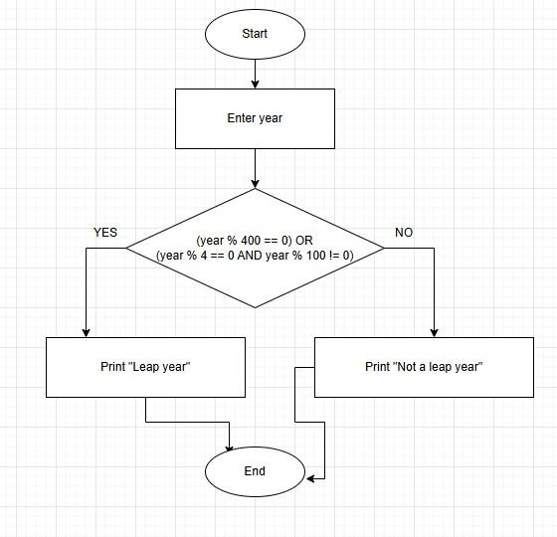

PYTHON CODE
year = int(input())
if (year % 400 == 0) or (year % 4 == 0 and year % 100 != 0):
print("Leap year")
else:
print("Not a leap year")
EXCECUTION
